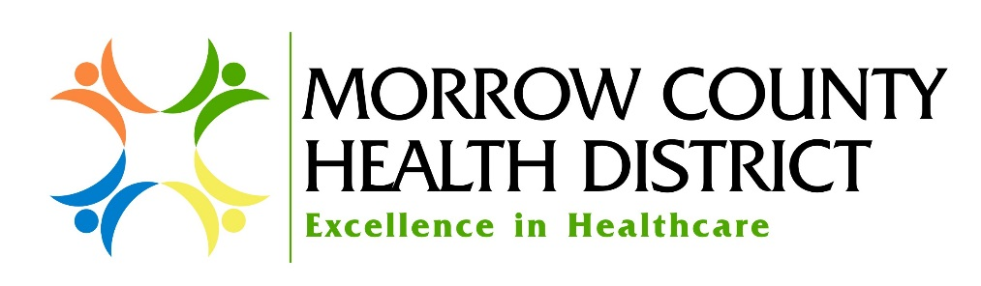
Employment at Morrow County Health District

Morrow County Health District believes that each employee makes a significant contribution to those we serve and the District as a whole. Every day our patients, families, other healthcare providers, visitors and coworkers are always deserving of exceptional, friendly service and the highest level of quality care possible. This is made possible by all employees agreeing to adhere to the District’s Promise of Excellence and upholding our True North Statement of “Welcoming our patients and providing exceptional care.”
Your contribution to the District and those we care for is not limited by the responsibilities set forth in this position description. This description is designed to outline primary duties, qualifications and job scope, but not limit the employee nor the organization to just the work identified. It is our expectation that each employee will offer his/her services wherever and whenever necessary.

Title: Director of Quality and Risk Management Department: Nursing

Exempt/Non-Exempt: Exempt Reports to: Chief Nursing Officer

Pay Equity Group: _____________ Effective Date: 09/13/2022

General Position Summary:

The Director of Quality and Risk Management interacts daily with the department directors and leadership of Morrow County Health District to coordinate and oversee the performance improvement efforts, Risk Management and Patient Safety efforts, and regulatory compliance.
The Director of Quality/Risk is responsible for the District’s Quality Improvement (QI) Program, Quality Assurance (QA) Program, and Risk Management. The Director manages and maintains databases associated with the programs, identifies trends, prioritizes and recommends improvements, works to decrease duplication, and ensures compliance with federal and state quality initiatives. Extracts data from electronic health records system and provides reporting support to department managers, physicians, and administration. Reviews standards of care, compliance with regulations. Implements patient safety processes, conducts risk assessments, submits quality data to governmental agencies, and develops department policies.

Essential Functions:

- Directs, monitors and evaluates the hospital-wide Risk Management and Patient Safety Program in compliance with federal and state regulations. Integrates the Risk Management and Patient Safety Program with The Districts primary functions.
- Responsible for the design, development and implementation of The District’s Quality Improvement and Quality Assurance Programs. Is accountable for timely program revisions to meet regulatory requirements.
- Analyzes updates and modify standard operating procedures and processes to continually improve QI reporting. Assists in strategizing and facilitating various committee structures and functions to best address the QI process and improvements.
- Creates reports and extracts data from the electronic health record for several quality initiatives, including MBQIP, HCAHPS, PQRS, and EDTC.
- Responsible for integrated Quality Assurance Program for all District departments. Coordinate QA meetings and reporting. Compiles statistical data and reports on results as they relate to QA issues.
- Perform data collection, analyze data for trends, and conduct data submission activities.
- Conduct performance improvement activities.
- Create reports and extract data from the electronic health record for various quality initiatives – for example: CORE and ENCORE Dashboards, MBQIP, HCAPS, PQRS, EDTC.
- Is responsible for integrated Quality Assurance Program for all District departments. Coordinates QA Meetings and reporting. Compiles statistical data and reports on the results thereof as it relates to Quality Assurance issues.
- Monitors and ensures compliance with CMS requirements. Helps departments be survey ready at all times.
- Lead Quality Functional Teams
- Create an annual Education Plan to promote staff knowledge and understanding of risk management, loss prevention, and regulatory compliance issues as well as The Districts performance improvement process.
- Participate in proactive team efforts to achieve departmental and company goals.
- Participate in the District Committees as assigned
- Assist with patient complaints.
- Maintain strict patient confidentiality and follow all HIPAA regulations.

Secondary Functions:

- Reviews Quality Assurance standards, assesses, develops and updates District policies and procedures, and works with District personnel to evaluate and improve effectiveness of monitors.
- Maintains and updates QA policies and procedures utilizing the specific expert knowledge of each key department staff.
- Review periodic Quality reports with Administration and other department managers.
- Provide limited supervision of assigned quality tasks through motivation, direction, review and feedback.
- Assist with CMS survey work.
- Attend all required meetings and complete all assigned education by due date.
- Oher duties as deemed appropriate by the CNO or District leadership.

Job Scope:

Supervisory Responsibility:
The Director of Quality/Risk has no supervisory responsibilities.

Interpersonal Contacts:
Excellent professional interpersonal communication skills are required for in-person, phone and email communications. The Director of Quality/Risk is in constant communication with various hospital and clinic staff. A demonstrated understanding and appreciation for diverse cultures is required. Must be able to interact with others in a thoughtful and professional manner.

Specific Job Ability:
Must be detail oriented, organized, and be able to manage priorities. Requires excellent verbal and written communication skills as well as strong analytical and problem solving skills. Must be able to manage projects within deadlines. Must have excellent computer skills for email, accessing electronic medical record information, data gathering, compiling reports and other duties

Specific Job Effort:
- Flexibility to work remotely from a home office and on-site. Must be onsite 2-3 days a week.
- Be able to sit, stand, and bend throughout the day.
- Be able to push, pull and lift over 10 pounds, occasionally over 50 lbs., possibly assist with lifting and moving patients.
- Responsible for meeting various requirements, conducting various department-related meetings, submitting reports and retaining records as required.
- Must possess adequate vision, hearing, and manual dexterity to perform job duties.
- Mental efforts of the position include juggling many duties and responsibilities at once, and having to prioritize and reprioritize as needs change. May be stressful at times.

Education, Experience and Certification/Licensure:

- Completion of a formal Registered Nursing education program with a minimum of an Associates of Applied Science degree in Nursing, Bachelor Degree preferred.
- Three to five years clinical experience as an RN
- One to three years of experience in Quality/Risk management preferred.
- Current Oregon State RN License.
- Possess current BLS certifications.
- Valid driver’s license required.
- Must be versed in District safety policies and procedures and follow them at all times

Job Conditions

- Subject to falls, hostile and emotionally upset patients, family members and staff throughout the work day.
- Subject to exposure to blood, body fluids, infectious substances, hazardous chemicals, toxins and noise.
- Occasional exposure to grease, oils and dust.
- Requires manual dexterity including manipulating tools, equipment and other items on a regular basis.
- Position will require some travel between various points within the District, and some out of town travel for trainings.

___________________________________________ __________________
Employee Name Date

