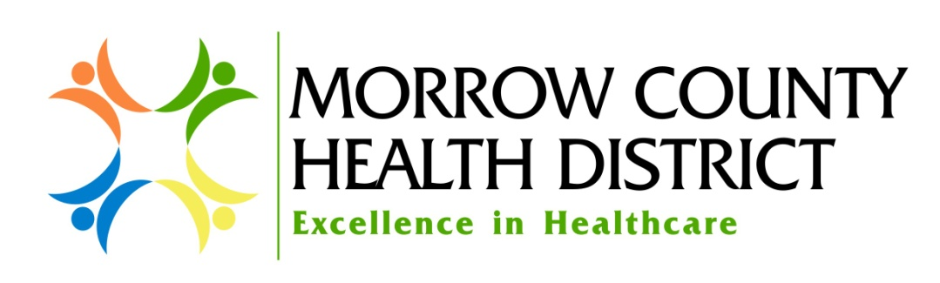
Purpose
The purpose of this policy is to establish the procedures used by Morrow County Health District (MHCD or the District) doing business as Pioneer Memorial District & Nursing Facility, Pioneer Memorial Clinic, Pioneer Memorial Home Health & Hospice, Irrigon Medical Clinic, Ione Community Clinic, and Morrow County Ambulance for billing and collection of patient account balances.

Policy
Patients with account balances that are their responsibility for payment will be billed to the patient or their guarantor pursuant to the provisions of this policy. Patient balances may be the result of assigned liabilities after payment from an insurance plan or government program such as Medicare, as well as liabilities from being uninsured. All billing and collection activities shall be in compliance with the District Fair Pricing Policies law, Section 501(r) of the Internal Revenue Code and Fair Debt Collection Practices Act.

Definitions
For the purpose of this policy the terms below are defined as follows:
Reasonable Efforts: A certain set of actions a healthcare organization must take to determine whether an individual is eligible for financial assistance under Morrow County Health District’s financial assistance policy.
Extraordinary Collections Actions (ECAs): As defined in Section 501(r) (6) of the Internal Revenue Code, ECAs are collection activities that may be taken against a patient or guarantor for non-payment that include but are not limited to:
- Reporting adverse information to credit agencies
- Placing a lien on an individual property except those allowed under state law due to judgements or settlements as part of a personal injury case
- Commencing civil action against an individual or writ of body attachment
- Garnishing an individual’s wages
Extraordinary collection actions does not include a lien asserted on the proceeds of a judgment, settlement or compromise owed to an individual as a result of a personal injury for which medical services were provided.
Financial Assistance: Healthcare services that have been or will be provided for free or at a discount to individuals who meet established criteria.
Financial Assistance Policy (FAP): A separate policy that describes Morrow County Health District’s financial assistance program, including the criteria patients must meet in order to be eligible for assistance as well as the process by which individuals may apply for financial assistance.

Procedures
- Initial Patient Billing

- Patients with or without insurance coverage will receive an initial patient billing statement at the next monthly billing cycle, customarily within 30 days of the date of service.

- All charges that are billed directly to a patient who is uninsured will be billed at the amount no greater than the amount generally billed to Medicare.
- The initial patient billing statement will include information on how to apply for financial assistance.
- For patients with primary insurance coverage, any balances remaining after the primary insurance payment; i.e. deductibles, co-payments, co-insurances, non-covered charges will be billed to the patient at the next monthly billing cycle, customarily within 30 days of the primary insurance payments.
- Statements of accounts to patients with balances secondary to a primary insurance payment will include information on how to apply for financial assistance.
- All patients may pay any amounts due over time and the District will negotiate a payment arrangement in good faith. If an agreement cannot be reached the District must accept the “reasonable payment plan” as defined by law.

- Statement Billing Cycles

- Balance due statements are customarily generated every 30 days after the date of the initial statement.
- Three statements will be generated by the District during the first 90 days, including the initial self-pay billing.
- 30 days after the first monthly billing statement is sent to the guarantor with no response or payment, patient account representatives will personally attempt to contact the patient/guarantor by mail and by phone until 90 days or more from the first monthly billing.
- After 90 days of reasonable attempts to establish a payment agreement or get a Financial Assistance application with no response, a final notice will be sent to the guarantor advising that the account will be assigned to a collection agency for ECAs in 30 days.
- Upon expiration of the 30 days on a final notice, the account will be written off to bad debt and referred to a collection agency. No account will be assigned to collections prior to 120 days from the first patient billing statement, nor while a financial assistance application is in process.

- Collection Agency Assignment Of Delinquent Accounts

- Patients enrolled in a formal payment plan and are making the monthly scheduled payments will not be assigned to collections unless the payment plan is delinquent.
- If a patient is covered under the District’s financial assistance program with an extended payment plan and the payments are not met, the District will take the following actions before an account can be assigned to a collection agency:
    - Make an attempt to contact the patient or guarantor at the last known phone number and address on file
    - Renegotiate the payment plan if there is a change in financial situation
    - If no contact can be made or the patient is unwilling to continue with payment plan or an updated plan;
    - A final notice will be sent to the guarantor advising that the account will be assigned to a collection agency for ECAs in 30 days.
- After the final notice for a delinquent account is issued the account is reviewed a final time before the assignment to a collection agency to ensure that a financial assistance application is not pending.
- If the FAP application is found to be pending due to an incomplete FAP application, and the individual has submitted a FAP application during the application period, the District will provide the individual written notice that describes the additional information and/or documentation required under the FAP or FAP application form that must be submitted to complete the FAP application.
- If the FAP application is subsequently completed during the application period, the individual will be considered to have submitted a complete FAP application during the application period.
- If the account is already assigned to a collection agency, the agency will put the account on hold during the duration of the application process and the collection agency will suspend any ECA actions.
- Requests for financial assistance shall be processed promptly and MCHD shall notify the patient in writing within 14 days of receipt of a completed application.
- Accounts will be sent to a collection agency for non-payment of the account and lack of applying for financial assistance or contacting the District to make payment arrangements.
- Patients who provide inaccurate demographic data and where the District cannot determine a valid address may be sent to collections earlier than 120 days. It is the guarantor’s responsibility to provide a correct address at the time of service or upon moving. If the address on the account is invalid or otherwise undeliverable to the individual, the determination for “reasonable effort” will have been made.
- The contracted collection agencies must follow the District’s financial assistance policy in all terms related to the application for assistance procedures and time frames, negotiating payment plans and the rules for engaging ECAs.
- ECAs will not be initiated against a patient during the first 120 days after the first billing statement was mailed; this includes negative credit reporting to credit bureaus.
- The patient will be informed in writing no less than 30 days before any ECAs are initiated.
- If a financial assistance application is made when an account is already assigned to a collection agency, the agency will put the account on hold for the duration of the application process.
- If the District is made aware of any verified Medicaid or other insurance coverage, the account will be recalled from the agency and the insurance billed for the service.
- Payments made directly to the District for accounts assigned to a collection agency will be reported to that agency on a daily basis.
- The fact that a patient has accounts in bad debt will not be used as a reason to deny future medical services at the District.
A copy of this policy may be requested by mail, free of charge, or by calling
MCHD Patient Business Office at (541) 676-9133 or 1-800-737-4113, or obtained in person at:
Pioneer Memorial Hospital, 564 E Pioneer Drive, Heppner OR 97836
Pioneer Memorial Clinic, 130 Thompson, Heppner OR 97836
Pioneer Memorial Home Health & Hospice, 162 N Main, Heppner OR 97836
Ione Community Clinic, 365 W 3rd St, Ione OR 97843
Irrigon Medical Clinic, 220 N Main, Irrigon OR 97844

